|  |  |  |  |  |
| --- | --- | --- | --- | --- |
| C:\Users\dautet\Desktop\School Pics\School photos 073.JPG |  | |  | | --- | | Chief Mistawasis School News  December, 2017 | | Issue Date | |
|  |  |  |
|  |  | Upcoming Dates to remember |

Tansi. Where has the time gone? It seems like we were just welcoming back all of our students to a new school year. Everyone is busy decorating and practicing for Christmas Concert. I am so proud of all of the students and staff at Chief Mistawasis School, and proud to be from Mistawasis Nehiyawak. The students are very lucky to have a great group of people who care for them, plan fun activities and give our students the opportunity to experiences so many amazing things. I love listening to the students reciting Cree words and singing Cree songs. I am proud of our Cree culture. We have such great values, teachings and Indigenous ways of knowing and being. Merry Christmas and a Happy New Year from all the studnts and staff at Chief Mistawasis School.

Hiy Hiy

**LOST ITEMS**

# From the Principal’s Desk

We are missing the inside parts (guts) of all of our coffee pots. If you know where they are can you please return them to the school. We cannot make coffee without them!!

**Allergy & Electronic Device Reminder**

Just a friendly reminder about thenut and microwave popcorn allergies that we have in our school. Please ensure that your child does not bring any food items containing nuts, and no microwave popcorn please. Also remind your child that electronic devices need to be left at home.



Important Dates to Remember

**Dec. 5- Spelling Bee**

**Dec. 7- Cabin Fun Day**

**Dec. 11- Family Fun Night**

**Dec. 14- Christmas Concert**

**Dec. 17-22- Spirit Week**

**Dec. 19-Literacy Night**

**Dec. 22- Early Dismissal 12:00**

**Dec. 25-Jan. 5- Christmas Holidays**

**Jan. 8- Classes resume**

**Mistawasis Nehiyawak Volunteer Program**

This year there is a new application process for any person who wants to volunteer for activities involving children and youth in the community.

Requirements include:

-Current Criminal Record Check (less than 3 months)

-completed application form

Applications available at the school or IBC. Getthem in early, as there will be no exceptions to this rule. All volunteers MUST be pre-approvedand provide a current criminal record check prior to going on any trips.

|  |
| --- |
| PHONE CALLS HOME |



Attendance Phone Calls

Parents please call the school if your child will be absent. If the school does not receive a call by 9:30, Yvonne Daniels, our school receptionist, will be calling home. This year we are trying to be more consistent with making these phone calls and having better communication with parents. In the event that there is a missing child, it is very important to have communication with everyone as quickly as we can.

Door Bell

We now have a new doorbell at the front door. No more knocking and hurting your knuckles. There is a sign by the doorbell saying to only ring the doorbell once, as we may be on the phone or away from the desk, so please have patience.

|  |
| --- |
|  |



### December Social Skills Program

RESPECT YOURSELF AND OTHERS

**Social Emotional Learning**

* Community
* Respect
* Manners
* Communication Skills
* Helping Others
* Inclusion
* Students will: learn specific ways they can be responsible members of their school community. Practice using good manners to show respect.

**Tipi Teachings and Bully Prevention**

* **Faith:** the student will learn to have faith in oneself, others and a higher power and to be true at heart. Develop pride and belief in ones self and in achievement of ones potential.

.

**Literacy Night**

**Tuesday, December 19**

**4:00-6:00**

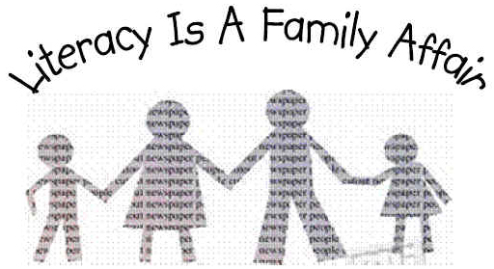

**At Chief Mistawasis School, we take pride in our community by being RESPECTFUL, HONEST, and RESPONSIBLE.**