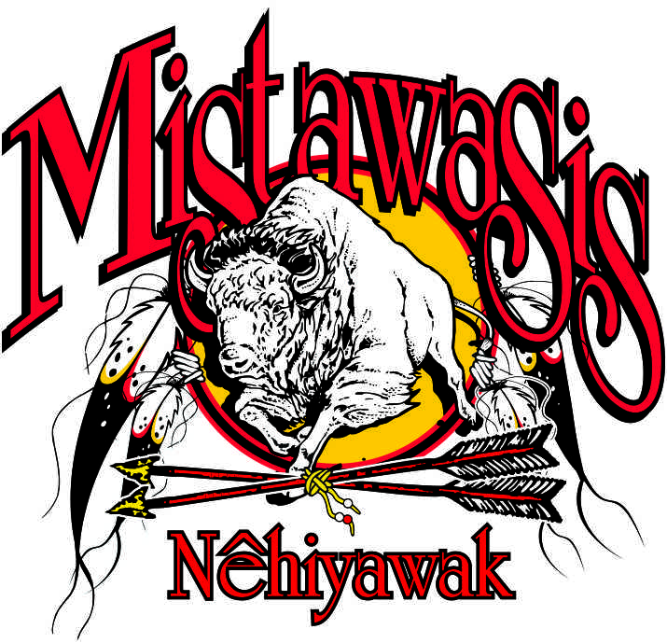Mistawasis Nêhiyawak

Box 250

Leask SK S0J 1M0

(TEL) 306-466-2390

(FAX) 306-466-2361

**File BCR #: ___________________________ Date: _______________________________**

Minor’s Full Name: _____________________________________________________

Date of Birth: ________________________________________

Registration Number: _________________________________________

**Statement:**

This is to confirm that if my child: _____________________________________________

is accepted as a member of the **Mistawasis Nêhiyawak Band**  and hereby consent to the removal of his/ her name from the ______________________________________ Band List and the addition of his/her name to the **Mistawasis Nêhiyawak Band List**.

**Parents Signatures:**

**Mother’s Signature:** ________________________________________

Address: __________________________________________________

Phone Number: ___________________________________

**Father’s Signature: _________________________________________**

Address: __________________________________________________

Phone Number: ___________________________________

**NOTE: Both parents must sign this consent form, if both parents are on the child’s birth certificate or unless one parent has legal custody, then a copy of the custody order is required.**